# InitEmmebank

The Phase 2.2 model is initialized from text files held in the BaseNetworks/ folder.

These files contain the following:

* Fundamental model parameters such as mode definitions, vdf/tpf/ttf formulations
* Seed matrices for initial auto demand and calibration matrices (Rij, and various mode specific adjustments, bus fare matrix, etc.)
* Truck and External demand for the given horizon year (2011, 2030, 2045)
* Input files required for performing an RTM model run which are copied to the Inputs/ folder of the databank that is created:
  + Land use files
  + Toll input files
  + TimeSlicing Factors
  + Settings.csv

Figure 1 – InitEmmebank Tool

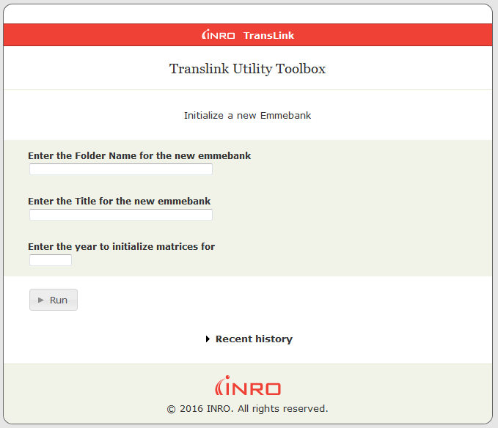

The required arguments are:

Folder Name – Name of the directory to be created within the EMME project containing a new databank

Title – The title of the emmebank

Year – The year for the Truck and External Demand matrices to be imported into the databank

# Run Model Network Expansion

The run model procedure has been modified to accept an additional parameter, the scenario containing the network to be run. This scenario will be copied into the appropriate time of day scenarios during the run model procedure.

AM Scenarios - 21000, 21030

MD Scenarios – 22000, 22030

PM Scenarios – 23000, 23030

This differs from the Phase 2 model which required the 21000 and 22000 scenarios to be created beforehand. In addition, the single source scenario now contains all of the information for all three time of day networks. This is accomplished with new extra attributes for each of the parameters used in the model run:

[LINK] Lanes - @lanesam, @lanesmd, @lanespm

[LINK] VDF - @vdfam, @vdfmd, @vdfpm

[TURN] TPF - @tpfam, @tpfmd, @tpfpm

[LINE] Headway (hdw) - @hdwyam, @hdwymd, @hdwypm

In order for your network changes to be reflected in the AM, MD and PM scenarios used in the model run, you must populate these extra attributes, and not simply the base attributes in the source scenario.

Figure 2 – Run Model Tool

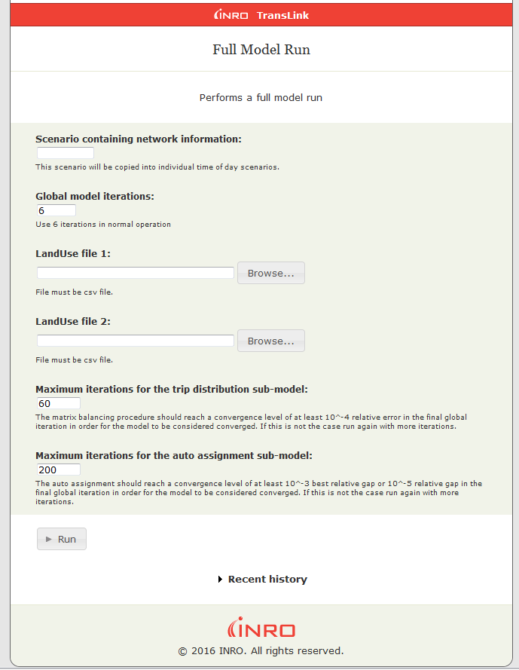

# Notes for Base Scenario Network Coding

## Modes

Modes are represented in the same manner as the Phase 2 model, with the addition of a new mode (v). This is the primary auto mode and must be coded on any link that is expected to be used by any of the other auto modes HOV[c], SOV[d], light truck[x] and heavy trucks [t].

## Lanes (@lanesam, @lanesmd, @lanespm)

Code the lane attributes in a similar manner to lane coding in the Phase 2 model. If a link should not be used in certain time periods, code the attribute with a 0 value. When the time of day network is built, links with zero lanes coded will automatically have the primary auto mode removed and will not be used in that scenario. Generally this is used in bus priority lanes or counterflow lanes that have selective availability during the day. If a zero-lane coding has been used, ensure that no transit services are using those links while using a tpf which contains the ‘timau’ variable, as this will cause a default ttf to be used instead (length/transit route default speed) which is likely not intended.

## VDFs (@vdfam, @vdfmd, @vdfpm)

Code the VDF attributes in a similar manner to the coding in the Phase 2 model, be aware of the possibly different number of available midblock and turning lanes at the intersection in different time periods.

## TPFs (@tpfam, @tpfmd, @tpfpm)

Code the TPF attributes in a similar manner to the coding in the Phase 2 model, this can be used to selectively limit turn movements during different time periods.

## Transit Headway (@hdwyam, @hdwymd, @hdwypm)

Code the TPF attributes in a similar manner to the coding in the Phase 2 model, this can be used to selectively enable transit itineraries for different time periods. If a headway value of 0 is coded for a particular time of day, that itinerary will be removed from the time of day scenario used in the model run.

# Network Modification Issues

## Issue 1 – Adding new Links

When adding new links that connect to a node defined as an intersection, be sure to review the new turns created as EMME will only auto-populate the tpf attribute, and not the time of day extra attributes, this could cause illogical turns to be allowed as the default value of the extra attribute is 0, which would disable all turns from or to the new link.

## Issue 2 – Adding new Intersections

Similar to Issue 1, when newly defining an intersection, ensure the extra turn attributes are coded to match the automatically set tpf values, otherwise all turns will be disabled at that node (tpf=0)

## Issue 3 – Adding new Transit services

When adding new itineraries, make sure the extra headway attributes are populated as expected, or the effective headway of 0 will cause these services to be removed when constructing the time of day networks.

# Model Run Issues

When running a model, ensure that the Inputs/settings.csv and the Inputs/toll_input.csv contain the values appropriate to the horizon year being run. These files are created automatically by the InitEmmebank procedure, but must be edited before use to ensure the desired parameters are set.

### tollinput.csv

By default, this file contains the 2011 tolled links. A 2015 (tollinput_2015.csv) and future (tollinput_all.csv) are provided for reference and each row is labeled with the purpose of the entry.

### settings.csv

The key entries to review are the horizon year entry and the congested transit assignment entry. The Phase 2.2 has not yet been updated to support congested transit and as such this should be set to ‘Off’. The number of processors used should also be set appropriately for the machine being used.